

Lethe: Agar's Island

**Game Concept & Design Document**

Lewis Arnold, Luke Baldwin, Jack Gilmour, Daniel Bailey

Urban Lizard Games

08.10.2020

# Game Overview

## Design goals

**Game design goal #1**

We want to create an atmosphere that instills tension and fear into the

player, thus causing them to imagine noises and threats when there are none.

**Game design goal #2**

To create an immersive storytelling experience in which the environment plays a large role in telling the story.

**What is the game?**

A puzzle horror game set in an abandoned cold war research facility on an island which the player must escape, using environmental clues to discover the story. The game will feature elements of psychological horror to keep the player on edge as they explore.

**Why create the game?**

With the return of classic puzzle horror games, like Amnesia, we feel there will be a large number of players of the genre, which will pick up the market enough for demand of a new solo psychological horror experience.

**Where does the game take place?**

The gameplay is all done on an abandoned island facility in the middle of the Bermuda Triangle.

**What do I control?**

The player will control a man stranded on Agar’s Island, and be able to interact with the environment to complete the puzzles so that they may escape the facility.

**How many characters do I control?**

The player plays only one character.

**What is the main focus?**

The main focus of the game is to survive and escape the abandoned island facility while potentially discovering the reason for its abandonment.

**What’s different?**

The location where the game is set is a unique one for games of this nature and the environment progresses the storyline rather than voice actors and NPC’s, which few games take advantage of.

# Feature Set

## General Features

3DGraphics

Exploration

Puzzles

Shaders

Gameplay Hazards

## Gameplay

Explore surroundings

Solve a variety of puzzles

Avoid enemy by making use of hiding spots within the level or use the flashlight to temporally dispatch enemies

Manage the character’s sanity to avoid the enemies attention.

3D sound to make the player more aware of their surroundings.

# The Game World

## Overview

The game world is Agar’s Island in Bermuda, on an unmarked island at the center of the Bermuda Triangle. There used to be an active cold war research facility on this hidden island, which is now abandoned and haunted by the experiments it created.

## The Facility

This facility used to house many horrible experiments carried out during the time of the cold war. Experiments not permitted to be conducted under the public eye. At least one remains and haunts the halls of the facility, an ominous gaseous type creature.

## Key Locations

Outer Facility

The abandoned facility:

The Facility Lobby

Generator Room

Lab 4

Communications Room

Holding Bays

Torture Room

## Travel

Primary method of travel will be walking with a faster sprint option for escaping enemies.

## Objects

Interactable puzzle pieces

Collectible items

Batteries

Sanity restoring meds

# Game Engine

## Overview

The game engine used in this project will be Unity3D 2019.4.12f1, the latest supported version of the Unity game engine. It is predominantly a 3D engine with a complete feature set for this game.

## Shaders

The 2019 version of Unity 3D introduced Shader Graph as an official feature. This will be used in the projects to produce great graphical effects while cutting down on development time and computer resources used by the game at run-time.

## Dynamic Lighting

Unity 3D offers dynamic lighting, which will be used sparingly to reduce the game’s computational overhead. The dynamic lighting will be used with objects like the torch, and more efficient baked lighting can be used on static lights.

## Camera

The camera will be positioned in a first person view during gameplay and will be very responsive to the player’s movements

# The World Layout

## Overview

The islands is host to the research facility which sits in the middle of the island

## Overground Map V1 (Work in progress)

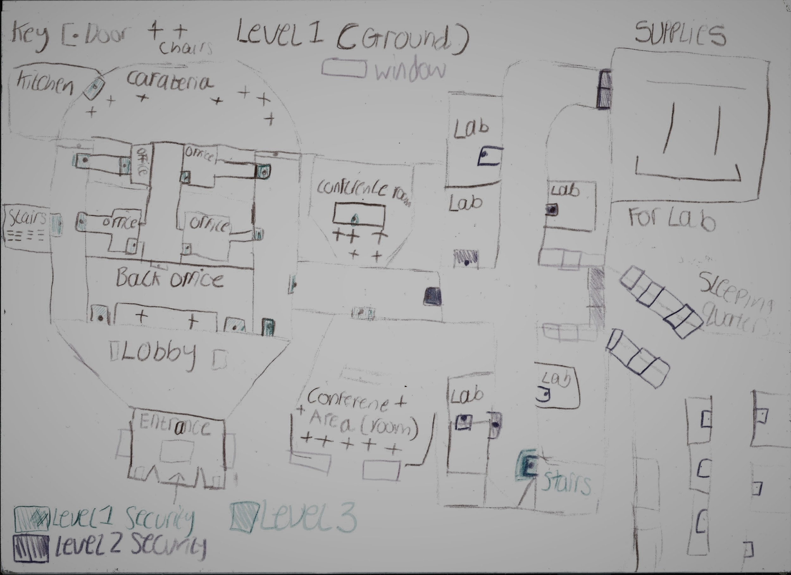

## Underground Map V1 (Work in progress)

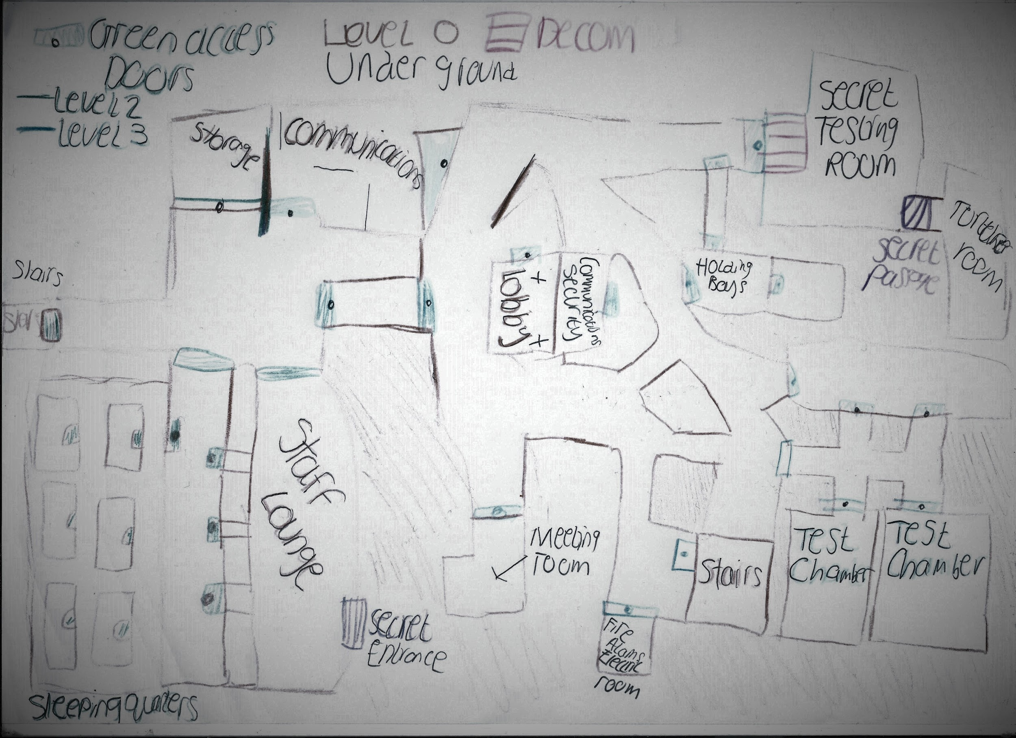

# Characters

## Overview

The player character is Bobby Bill from Kentucky who used to work as an official sounding government job and now has found their way to the island, knowing nothing of themselves. The enemy in this game is an experiment failure from the researchers who used to conduct research here.

## Player Character

No Model for player character, the player controls the character’s torch

**Player Stats**

|  |  |
| --- | --- |
| **Stat** | **Value** |
| Walk speed | 1.5 |
| Run Speed | 2.0 |
| Height | 178cm |
| Sanity Gain / second | 1 SU per second |
| Max Sanity | 100 SU |
| Batteries held | 2 with also one inside the torch |

## Enemies

There is one main enemy in the game, and they manifest no physical form. They will be rendered using the shaders described earlier. They are a failed experiment of the researchers who used to practice their under the table science on Agars Island. Left haunting the halls of the facility for years, anger and hatred has taken over and now their only wish is to puppet the next poor soul who walks in, and walk out themselves; ready to enact their revenge.

## Enemy Stats

|  |  |
| --- | --- |
| **Stat** | **Value** |
| Movement speed | 1.5 |
| Health | 100 |
| Height | 150cm |
| Sanity drain far | 1.5 SU per second |
| Sanity drain near | 5 SU per second |
| Sanity drain looked at | 10 SU per second on top of normal drains |

# User Interface

## Overview

The Interface will provide conventions of the horror and psychological horror genres. These conventions will be used to make the player feel like they are playing a full immersive horror game experience.

## The Menus

These menus will provide a dark and gritty theme and will provide the same feelings as what the abandoned facility will provide such as a lost and forgotten theme where the UI seems untouched and unmaintained. Examples of this would include the text being a font that represents this idea of it being broken, rotting and unmaintained.

# Weapons

## Overview

The only weapon in the game will be a flashlight.

## The flashlight

**Flashlight stats**

|  |  |
| --- | --- |
| **Stat** | **Value** |
| Range | 10m |
| Damage / s | 3 per second |
| Battery drain / s | 0.5% per second |

# Music + Sound effects

## Interaction / Player noise

* Torch On/Off
* Door Open/Close
* Valve turn
* Generator noise
* Button press
* Keycard accepted
* Keycard declined
* Low sanity ambience
* Heartbeat
* Torch battery changing
* Pick up item
* Read note
* Footsteps

## Ambient Noise

* Wire Spark
* Water drip
* Wind blowing
* Soft waves
* Crashing noises
* Whispers
* Low humming
* Computer fans whirring
* Bug noises

## Enemy Noises

* Smoke Wisps
* Hostile Growl
* Enemy chasing the player

# Single Player Experience

## Overview

Key components include completing puzzles to explore the abandoned research facility, running from the threats within, and hiding to escape when you can’t fight back.

## Story

The player is shipwrecked on an island, and has no idea how they got there. In front of them lies an abandoned facility of an unknown purpose. The player decides that the facility is the best route off the island and begins to uncover the purpose behind the facility and what led to its abandonment.

By finding different keycards, granting increasing levels of access to the facility, the player discovers that the facility was home to cold war experiments, more specifically, research into sentient gaseous bio-weapons. The experiments took a while to perfect but as they were perfected, the war came to an end and the facility was abandoned. This leads to the experiments being left to simmer in their anger for those who created them, having been abandoned without a care. They now roam the facility, writhing with anger, taking it out on the poor soul that finds themselves here. The player must avoid the monstrosities and make it off the island.

## Hours of Gameplay

2

## Victory Conditions

Exploring the whole of the abandoned research facility in order to gather the necessary resources to escape the island.

# Misc.

# Appendices

## Object Appendix

### Consumables Appendix

|  |  |  |
| --- | --- | --- |
| Consumable | Effect | Potency |
| Battery | Recharges torch | 100% charge |
| Sanity meds | Recharge sanity | 40 SU |
| Food resources | Increase stamina | 50% restoration |